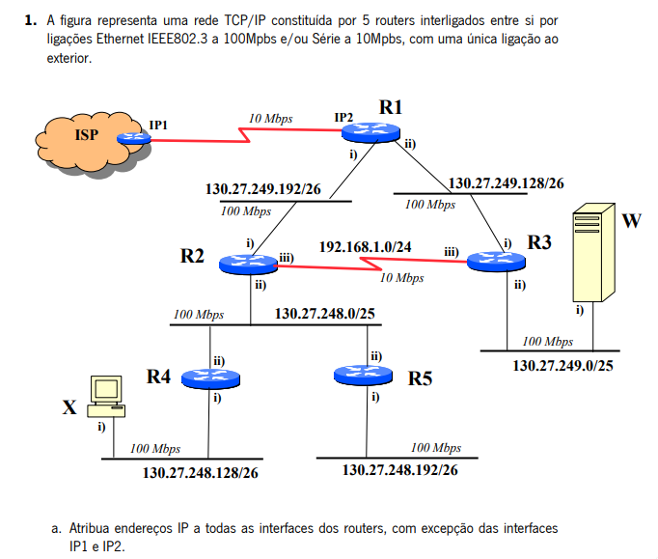

130.27.248.126

130.27.248.189

130.27.249.127

130.27.248.125

192.168.1.1

192.168.1.2

130.27.249.254

130.27.249.190

130.27.249.189

130.27.248.254

130.27.248.127

130.27.249.253

24-1

**25-2**

**256/2=128**

**0-128->1-127**

**128-255->129-254**

**26-4**

27-8

28-16

29-32

30-64

192.168.1.2

256/4=64->64-2=62 hosts p subrede

0-63 -->uteis: 1-62

64-127->65-126

128-191-->129-190

192-255-->193-254

R1:

i-130.27.249.254

ii-130.27.249.189

R2:

i-130.27.249.253

ii-130.27.248.127

iii-192.168.1.1

R3:

i-130.27.249.189

ii-130.27.249.127

iii- 192.168.1.2

R4:

i-130.27.248.190

ii-130.27.248.126

R5:

i-130.27.248.254

ii-130.27.248.125

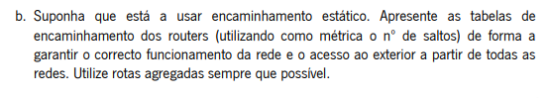

R1

|  |  |  |  |
| --- | --- | --- | --- |
| REDE DE DESTINO | INTERFACE DE SAÍDA | PRÓXIMO NÓ | CUSTO |
| 130.27.249.192/26 | 130.27.249.254 | ---- | 0 |
| 130.27.249.128/26 | 130.27.249.189 | ---- | 0 |
| 130.27.248.0/24 | 130.27.249.254 | 130.27.249.253 | 1 |
| 130.27.249.0/25 | 130.27.249.190 | 130.27.249.189 | 1 |
| 192.168.1.0/24 | 130.27.249.190 | 130.27.249.189 | 1 |
| 0.0.0.0/0 | IP2 | IP1 | ---- |

R2

|  |  |  |  |
| --- | --- | --- | --- |
| REDE DE DESTINO | INTERFACE DE SAÍDA | PRÓXIMO NÓ | CUSTO |
| 130.27.249.192/26 | 130.27.249.253 | ---- | 0 |
| 130.27.249.128/26 | 130.27.249.253 | 130.27.249.254 | 1 |
| 130.27.248.0/25 | 130.27.248.127 | --- | 0 |
| 130.27.248.128/26 | 130.27.248.127 | 130.27.248.126 | 1 |
| 130.27.248.192/26 | 130.27.248.127 | 130.27.248.125 | 1 |
| 130.27.249.0/25 | 192.168.1.1 | 192.168.1.2 | 1 |
| 192.168.1.0/24 | 192.168.1.1 | ---- | 0 |
| 0.0.0.0/0 | 130.27.249.253 | 130.27.249.254 | 1 |

R3

|  |  |  |  |
| --- | --- | --- | --- |
| REDE DE DESTINO | INTERFACE DE SAÍDA | PRÓXIMO NÓ | CUSTO |
| 130.27.249.192/26 | 192.168.1.2 | 192.168.1.1 | 1 |
| 130.27.249.128/26 | 130.27.249.190 | ---- | 0 |
| 130.27.248.0/24 | 130.27.249.254 | 130.27.249.253 | 1 |
| 130.27.249.0/25 | 130.27.249.127 | --- | 0 |
| 192.168.1.0/24 | 192.168.1.1 | --- | 0 |
| 0.0.0.0/0 | 130.27.249.189 | 130.27.249.190 | 1 |

R4

|  |  |  |  |
| --- | --- | --- | --- |
| REDE DE DESTINO | INTERFACE DE SAÍDA | PRÓXIMO NÓ | CUSTO |
| 130.27.249.128/25 | 130.27.248.126 | 130.27.248.127 | 1 |
| 130.27.248.0/25 | 130.27.248.126 | --- | 0 |
| 130.27.249.192/26 | 130.27.248.126 | 130.27.248.125 | 1 |
| 192.168.1.0/24 | 130.27.248.126 | 130.27.248.127 | 1 |
| 130.27.249.0/25 | 130.27.248.126 | 130.27.248.127 | 1 |
| 130.27.248.128/26 | 130.27.248.189 | ----- | 0 |
| 0.0.0.0/0 | 130.27.248.126 | 130.27.248.127 | 2 |

R5

|  |  |  |  |
| --- | --- | --- | --- |
| REDE DE DESTINO | INTERFACE DE SAÍDA | PRÓXIMO NÓ | CUSTO |
| 130.27.249.128/25 | 130.27.248.125 | 130.27.248.127 | 1 |
| 130.27.248.0/25 | 130.27.248.125 | --- | 0 |
| 130.27.249.192/26 | 130.27.248.125 | 130.27.248.126 | 1 |
| 192.168.1.0/24 | 130.27.248.125 | 130.27.248.127 | 1 |
| 130.27.249.0/25 | 130.27.248.125 | 130.27.248.127 | 1 |
| 130.27.248.192/26 | 130.27.248.254 | -- | ---- |
| 0.0.0.0/0 | 130.27.248.125 | 130.27.248.127 | 2 |

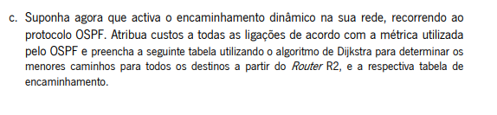

Segundo o ospf a métrica=10⁸/x bps-->100Mbps=100*10⁶bps=10⁸ bps

100Mbps=>1 metrica ospf

10Mbps=>10 metrica ospf

|  |  |  |  |  |  |  |
| --- | --- | --- | --- | --- | --- | --- |
| Passo | N | D(R1),P(R1) | D(R3),P(R3) | D(R4),P(R4) | D(R5),P(R5) | ISP |
| 0 | R2 | 1,R2 | 10,R2 | 1,R2 | 1,R2 | ∞ |
| 1 | R2,R1 | ----- | 2,R1 | 1,R2 | 1,R2 | 11,R1 |
| 2 | R2,R1,R4 | ------ | 2,R1 | ----- | 1,R2 | 11,R1 |
| 3 | R2,R1,R4,R5 | -------- | 2,R1 | ------ | ---- | 11,R1 |
| 4 | R2,R1,R4,R5,R3 | ----- | ----- | ------ | ----- | 11,R1 |

Tabela de encaminhamento ospf

|  |  |  |  |
| --- | --- | --- | --- |
| DESTINO | INTERFACE DE SAÍDA | PRÓXIMO NÓ | CUSTO |
| R1 | R2-i | R1-i | 1 |
| R3 | R2-iii | R3-iii | 2 |
| R4 | R2-ii | R4-ii | 1 |
| R5 | R2-ii | R5-ii | 1 |
| ISP | R2-i | R1-i | 11 |